* **Addition of more Raw HDD to a Server**

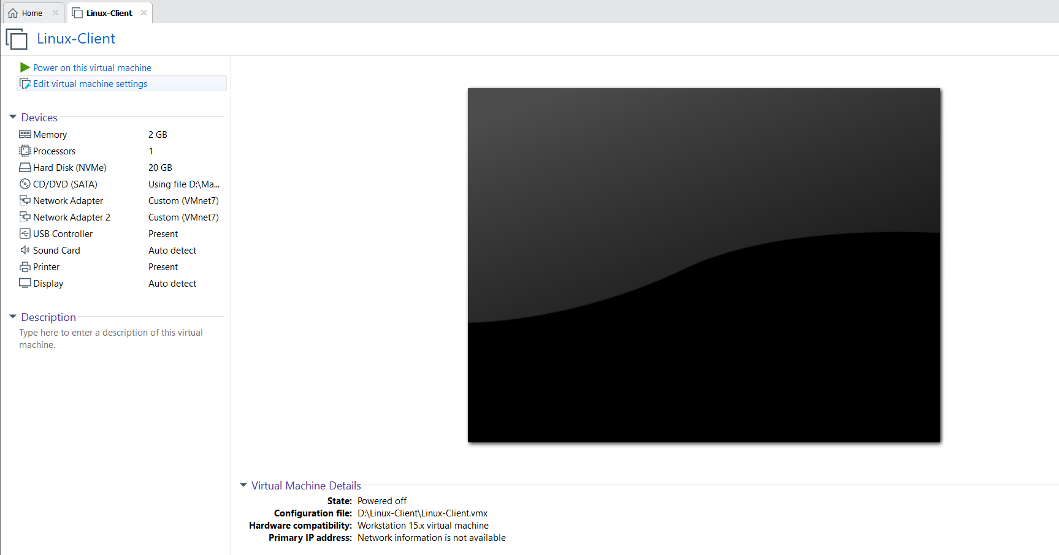

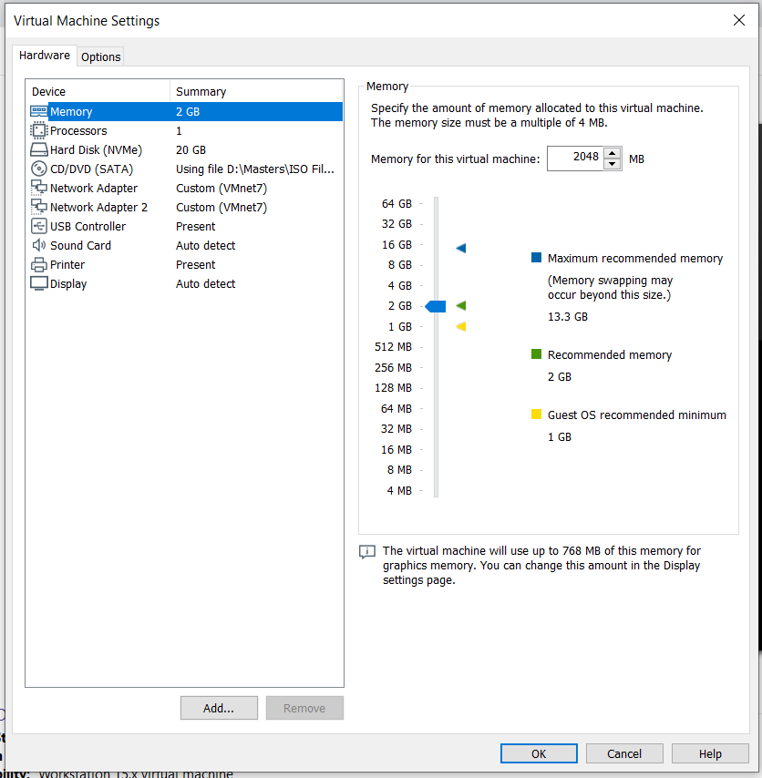

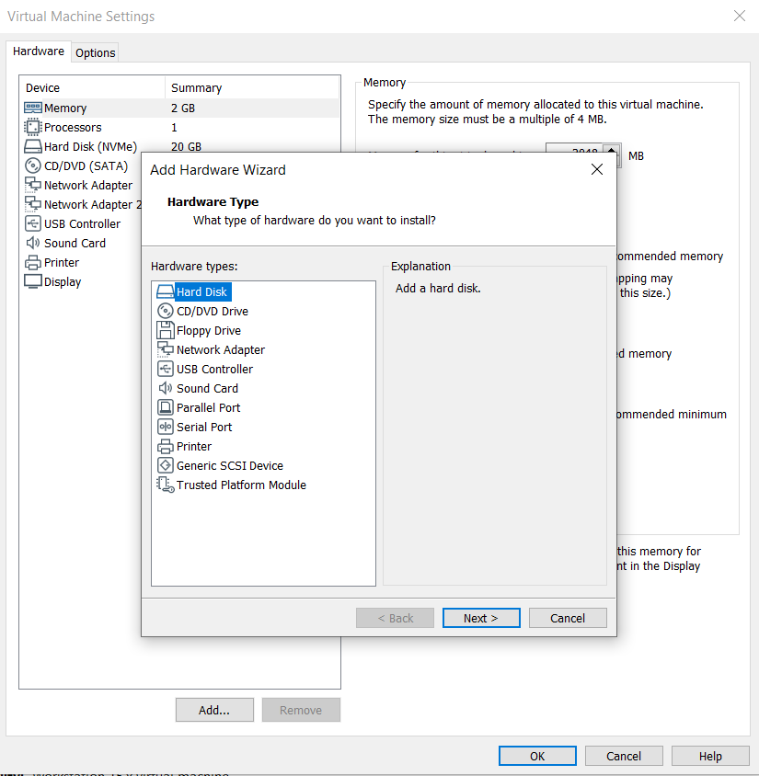

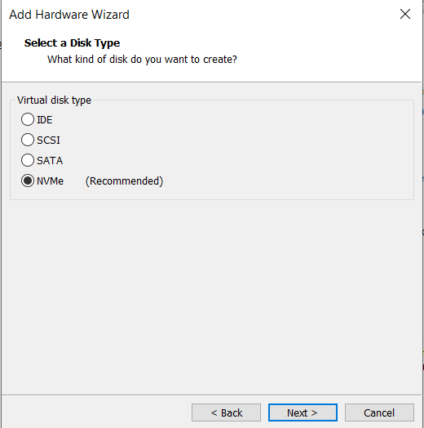

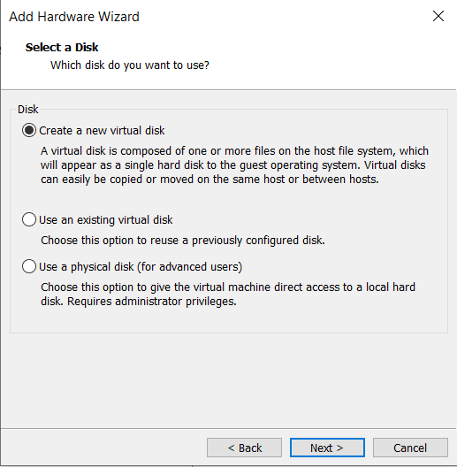

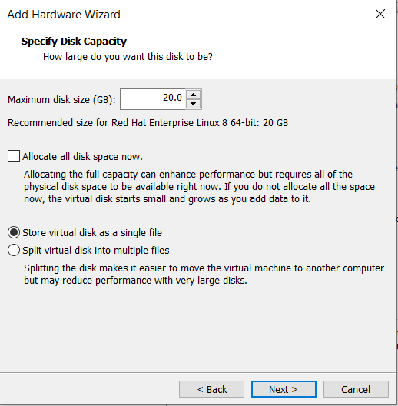

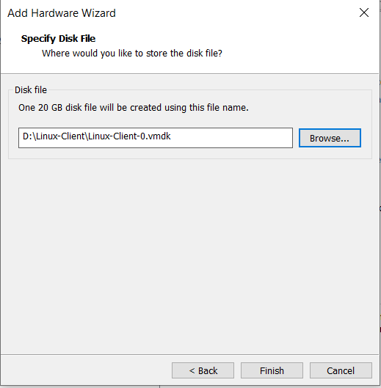

* **Turn on the Virtual Machine & login through root user, it should look like this.**

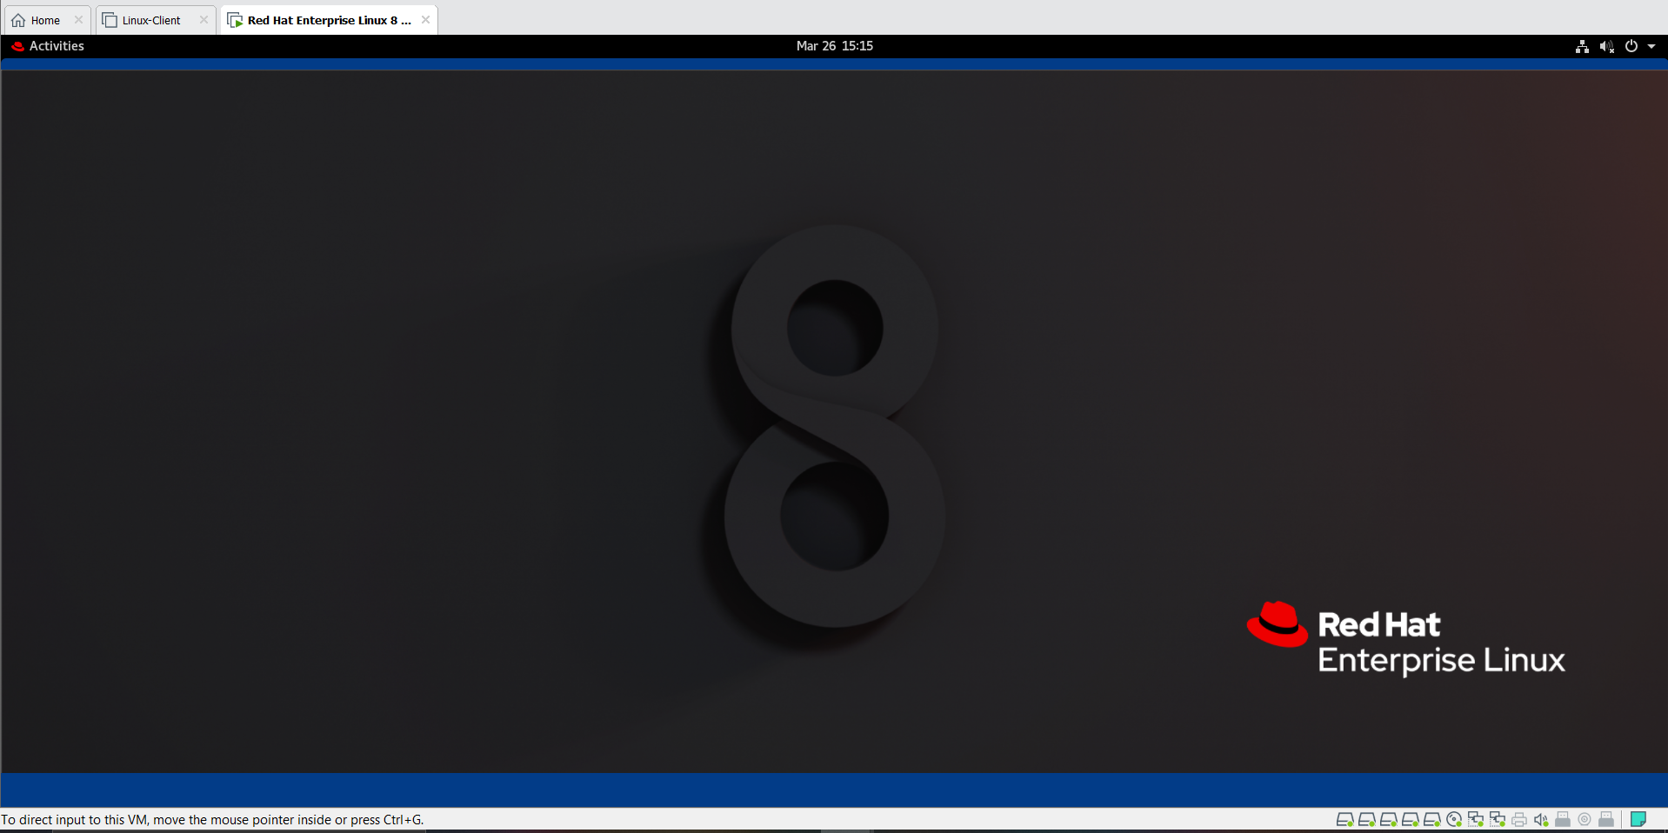

* **Command to check how many raw HDD are attached to the system & how many partitions are made.**

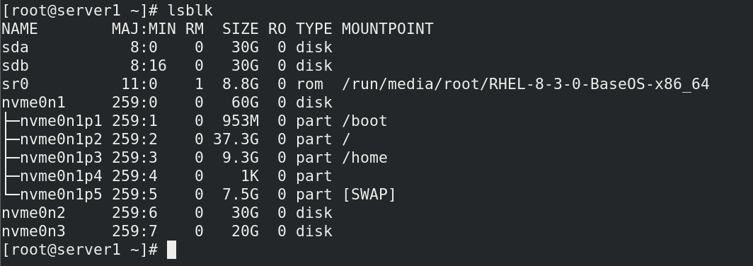

**MSDOS Style Partition Table**

* **At First, when a raw HDD is connected to the system, it is not ready for use to store data, to make the HDD ready for use we assign them a partition table to that raw HDD, which will help the OS to recognize the HDD and the partitions that is created in it.**

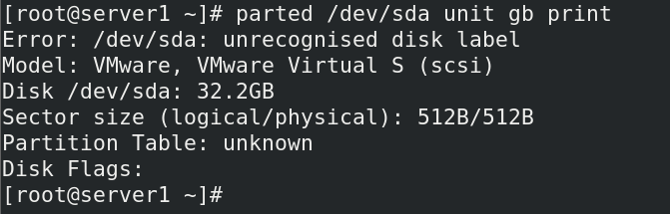

* **Now assign the Partition table {msdos} for the raw HDD before creating partitions into it for storing data.**



* **Verify the assigned partition table, as we are first working with msdos partition table.**

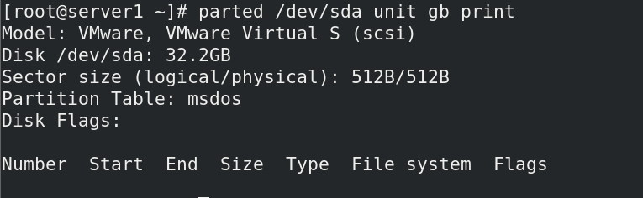

* **Now start creating 4 partitions into the HDD (sda)**

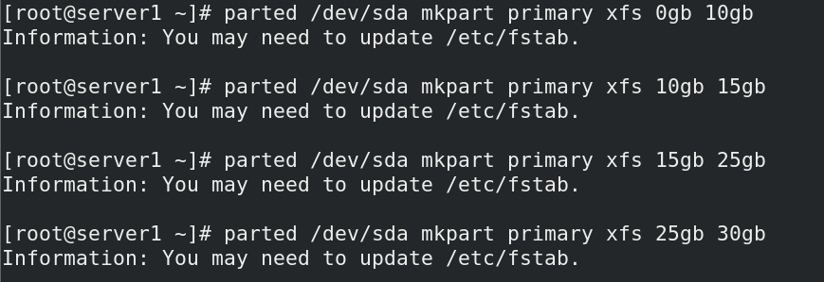

* **Verify the created partitions**

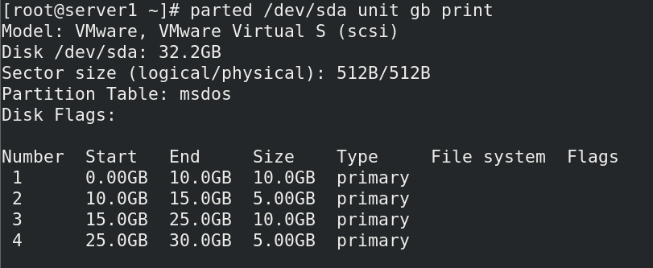

* **After creating partitons, use this command for letting the OS know about all the partitions created.**

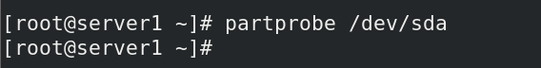

* **Now before mounting these partitions onto the mountpoint you need to format these partitions & make It ready for use. Here I am using XFS file system to format these partitions.**

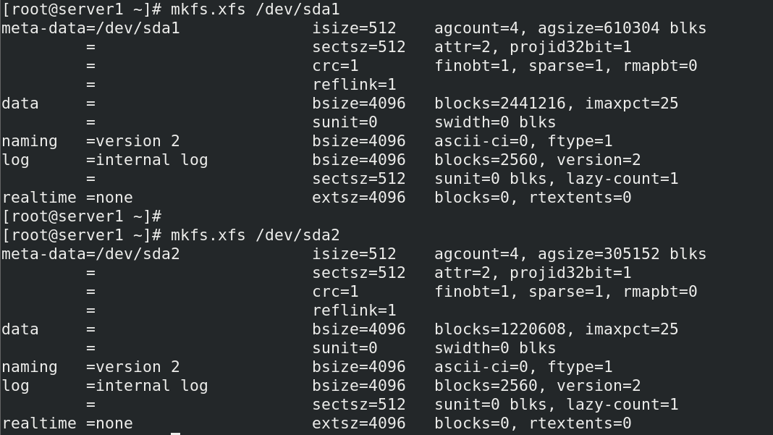

* **Create folders that will act as mountpoints for our created partitions.**



* **Now mount these partitions onto the mountpoints.**

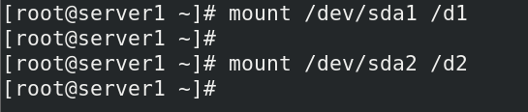

* **Verify if the partitions are mounted properly on the mountpoints.**

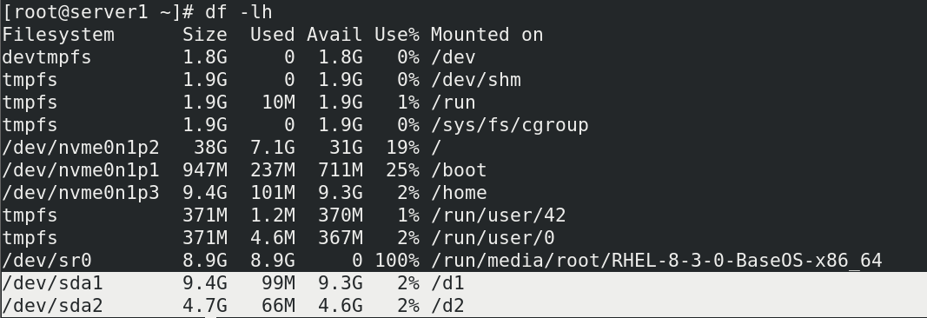

* **Creating some data into these respective folders, will in short it will store data into the HDD partitions. For example in this case, when some data is created in directory d1 means it will indirectly use /dev/sda1 partition for storing of this data.**

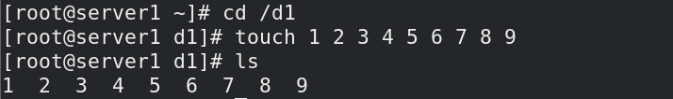

* **Mounting done previously is just temporary mounting means when you restart the server, all the mounted partitions will be unmounted. So, for persistent mounting you need to make an entry into the /etc/fstab file for making this mount a permanent mount.**



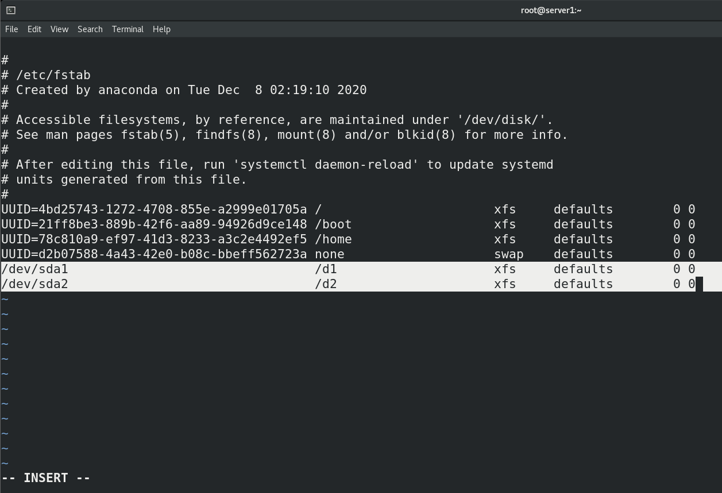

* **Below commands will reload the Daemon & will again mount all the partitions whose entries are made into /etc/fstab file.**

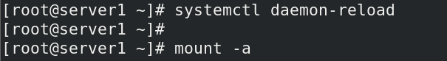

* **Verfication of Mounted partitions again**

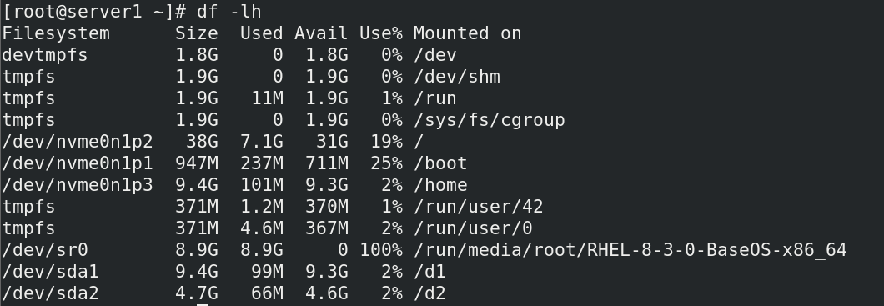

**GPT Style Partition Table**

* **Command to check how many raw HDD are attached to the system & how many partitions are made.**

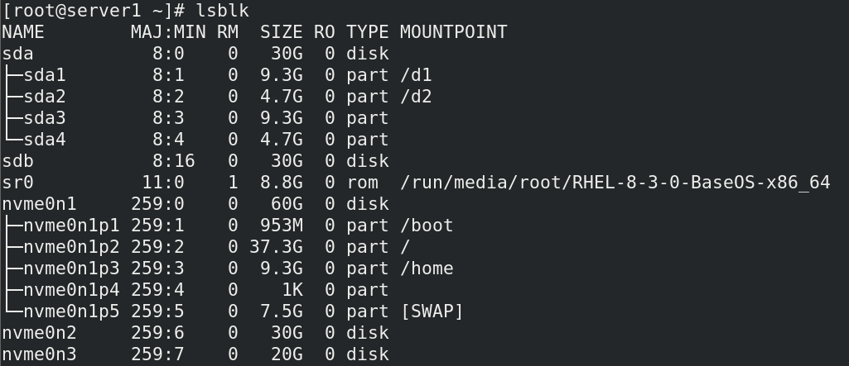

* **At First, when a raw HDD is connected to the system, it is not ready for use to store data, to make the HDD ready for use we assign them a partition table to that raw HDD, which will help the OS to recognize the HDD and the partitions that is created in it.**

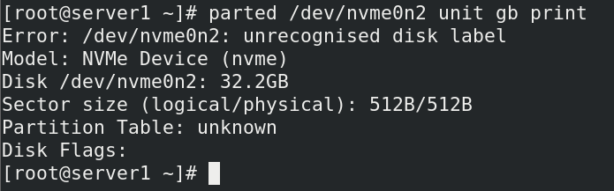

* **Now assign the Partition table {msdos} for the raw HDD before creating partitions into it for storing data.**



* **Verify the assigned partition table, as we are first working with gpt partition table.**

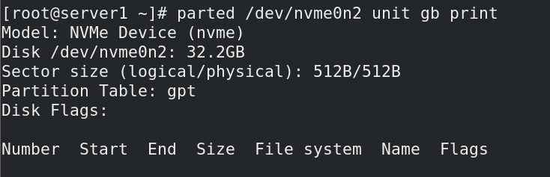

* **Now start creating 3 partitions into the HDD (nvme0n2)**

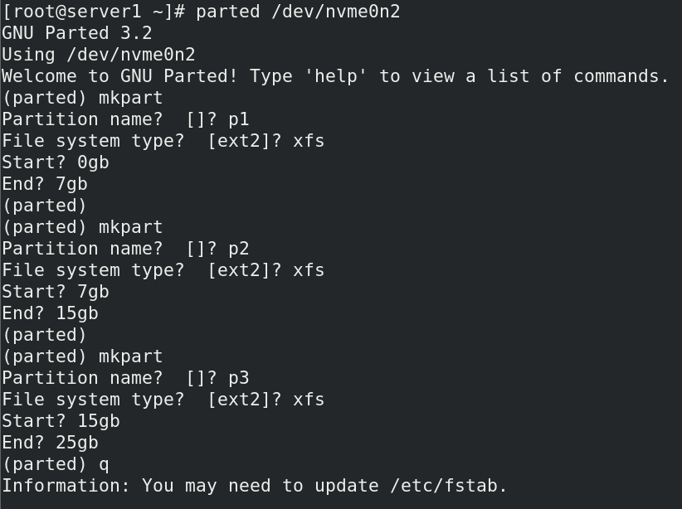

* **Verify the created partitions**

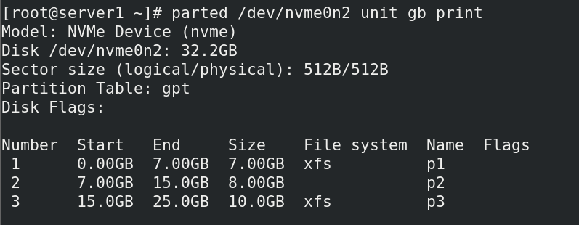

* **Now before mounting these partitions onto the mountpoint you need to format these partitions & make It ready for use. Here I am using XFS file system to format these partitions.**

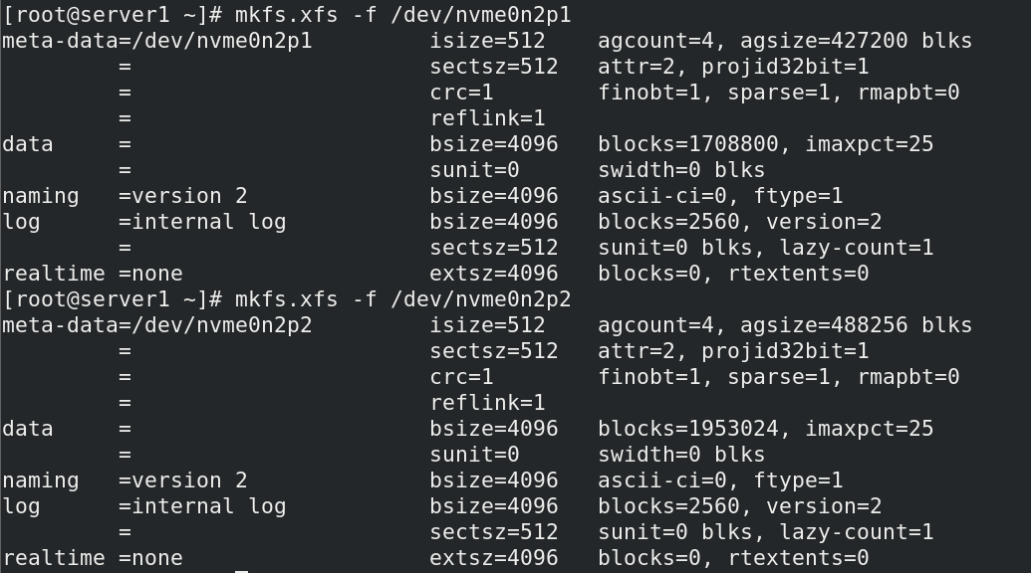

* **Create folders that will act as mountpoints for our created partitions.**



* **Now mount these partitions onto the mountpoints.**

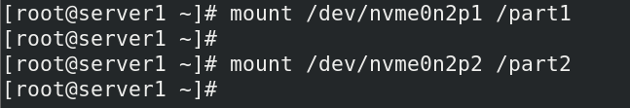

* **Creating some data into these respective folders, will in short it will store data into the HDD partitions. For example, in this case, when some data is created in directory d1 means it will indirectly use /dev/sda1 partition for storing of this data.**

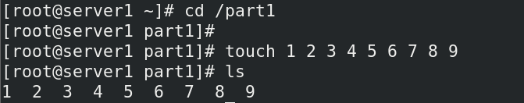

**Mounting done previously is just temporary mounting means when you restart the server, all the mounted partitions will be unmounted. So, for persistent mounting you need to make an entry into the /etc/fstab file for making this mount a permanent mount.**

* **Command to get the UUID for the partitions**

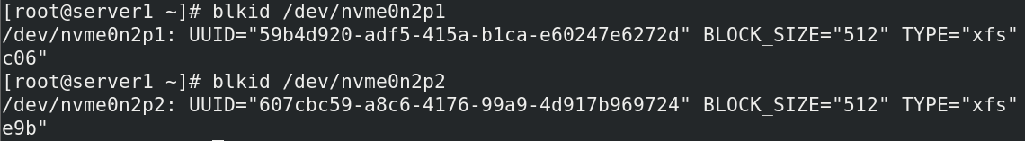

* **Making an entry of the partitions using its UUID in the /etc/fstab file for persistent mounting.**



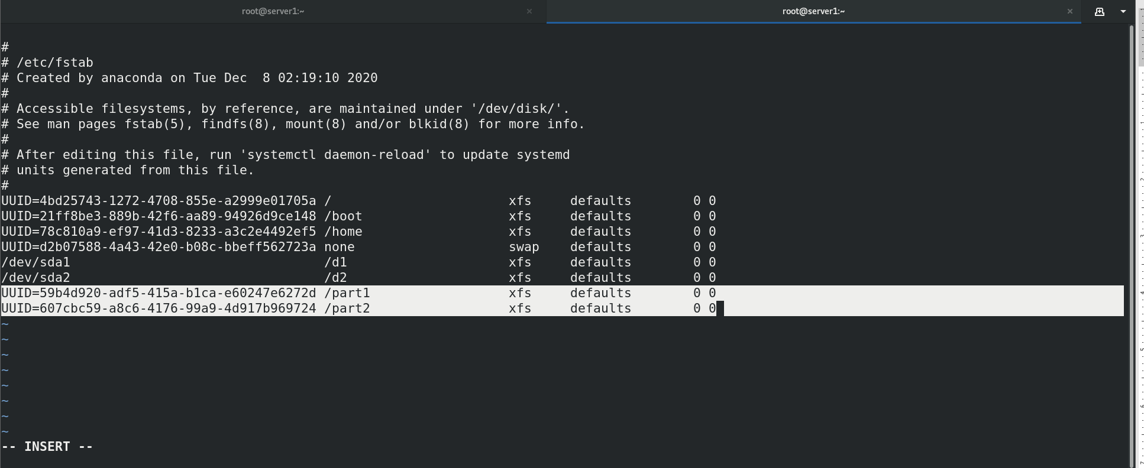

* **Below commands will reload the Daemon & will again mount all the partitions whose entries are made into /etc/fstab file.**

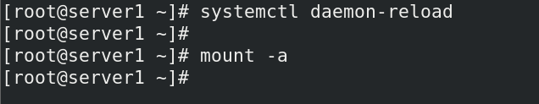

* **Verfication of Mounted partitions again**

